Former Oakland School & Glebe Land Site, Bayston Hill

BS 5837 Tree Survey and Report

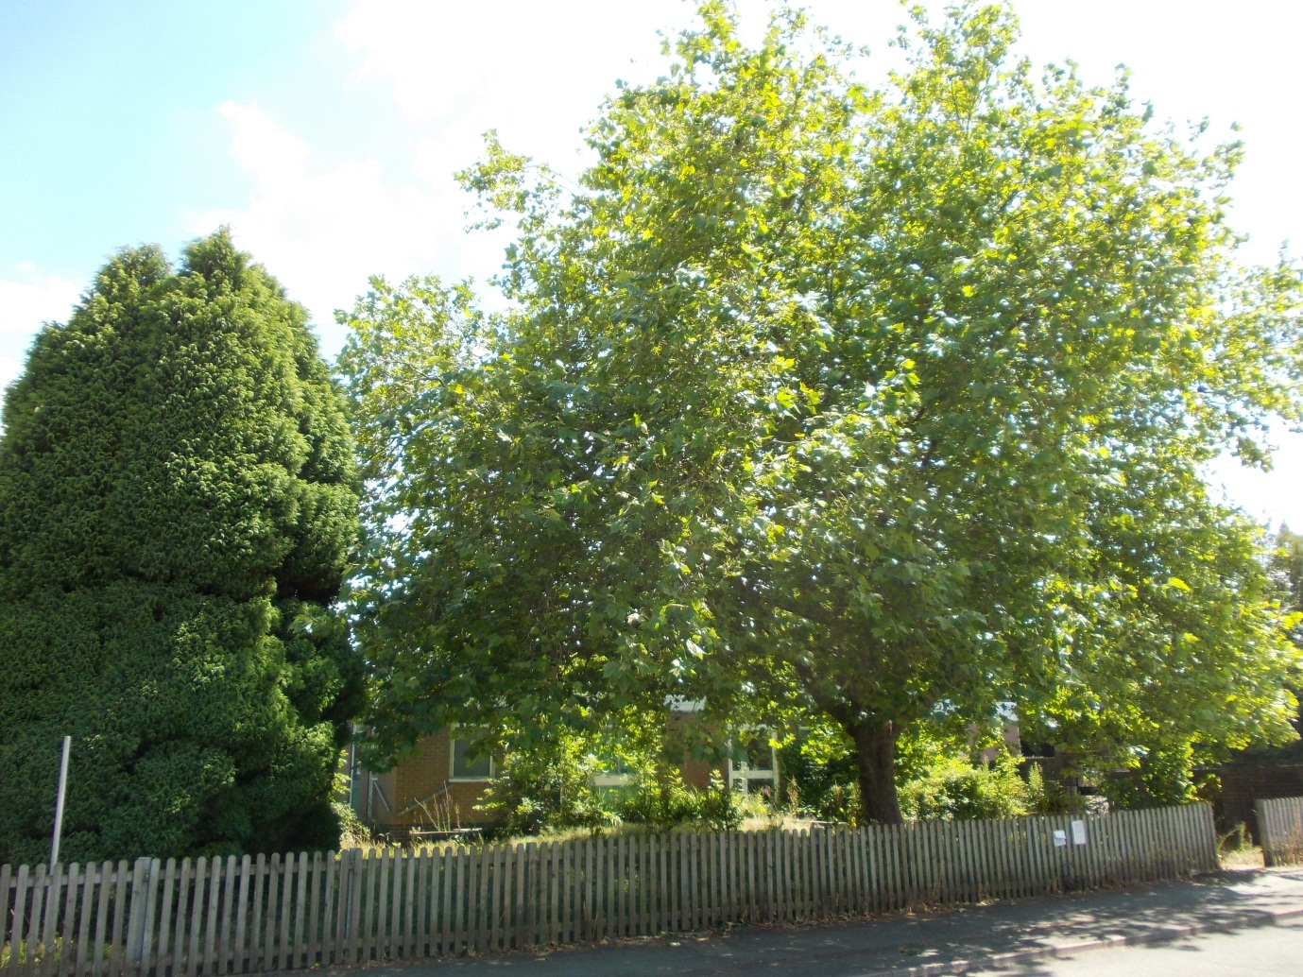

- Scope of Survey

  - A survey of all the trees on the former Oakland School site, the Glebe Land site, the open space area on the east side of Christ Church and York House and Bayston Hill Public Library was undertaken by Siobhan Reedy and David Woodhouse on 10th and 11th July 2014.

  - The former Oakland School and the Public Library are sites in Shropshire Council’s ownership, the Glebe Land, and area to the side of Christ Church are owned by the Diocese of Lichfield and the land at the side of York House is owned by York House.

  - The survey was undertaken in response to a request from Jane Kenyon, Asset Management Officer, in the Strategic Asset Management Team, for information on the possible tree constraints on all the sites, prior to an outline planning application being submitted for development of these sites.

  - The information in this report is intended as preliminary guidance to help inform officers of the tree constraints that need to be considered and incorporated in any outline planning application.

  - Further information in the form of a tree protection plan showing the tree root protection areas (RPA’s), the position of protective barriers and all other constraints detailed in this report will need to be provided along with an arboricultural impact assessment prior to detailed planning permission being granted.

  - This report and survey have been produced using the methods and principles defined by BS5837: 2012 Trees in Relation to Design, Demolition & Construction. The survey was carried out from ground level with basic diagnostic tools and using the VTA method of assessment.

  - This report is valid for 12 months from the date given. Where work recommendations have been made they should be completed within the recommended timeframes.

  - Trees are natural living entities subject to changes in their natural environment over time. The health and condition of the surveyed trees relates therefore only to what was seen at the time of inspection.

- Tree Survey – Main Findings

  - The most significant trees across the combined sites have been given an “A” category rating. Eight individual trees and two groups have received this rating. These trees are located at:

    - The front of the public library (G3).
    - The front of the former Oakland School building and playground, facing on to Glebe Road (T5, T26).
    - On the eastern boundary of the former Oakland School site, adjacent to the rear of 62 Lyth Hill Road (T12)
    - In front of the Scout Hut on Eric Lock Road West (T34)
    - Along the southern boundary of the former school playing field and the Glebe Land, in the dense hedging behind the properties in Lyth Hill Road (T20, T28, G29, T30)
    - At the front of the church facing on to Glebe Road, (T40)

  - Three of these “A” category trees are protected by a Tree Preservation Order, they are T5, T12 and T26. There is also one “C” category tree which is also covered with a TPO, this is T19.

  - A number of the mature oaks situated on the southern boundary of the former school and Glebe Lands site can be described as veteran trees. Veteran trees are trees of a great age and /or trees with characteristics associated with great age. All of these veteran trees have very large stem diameters, which is indicative of great age.

  - Unfortunately due to the very dense hedging surrounding these trees it has only been possible to estimate their stem diameter, nevertheless they are obviously very large and very old. In fact they are likely to be some of the oldest trees in the Bayston Hill area and consequently are of local significance. Their location in the mature hedge line points to this being the remnants of an ancient boundary which long predates the post war development of Bayston Hill.

  - There must/should be a presumption in favour of retaining these veteran trees along with all the other “A” category trees across the sites. The constraints relating to retaining these trees are detailed further on in this report.

  - There are three trees situated on adjoining private properties, outside the boundary of the proposed development areas, which overhang the proposed development sites, (T1,T7 & T8).These trees have been included in this survey because they partly overhang the proposed development areas and at least part of their root zones extend in to the site. Their stem diameters have been estimated and therefore the root protection areas detailed in the schedule may not be completely accurate.

  - T1is a dying elm and therefore it is recommended that the owners of this tree are advised that it should be felled, irrespective of the future redevelopment of the library site.

  - The precise location of the site boundary on the southern side of the former Oakland School site and the Glebe Land is unclear because at least part of this area has a ditch and watercourse running through it and some of the trees are located on the far side of this ditch, whilst others are located on the near side. Also there is a footpath and fence at the rear of the former Oakland playing field behind which some of these trees are located. All of the tree in this area are situated in dense hedging/scrub. This is the area where the veteran oak trees are located. It will be necessary to identify the exact boundary before any development proposals are submitted or the site is sold.

- Development Constraints

  - All trees detailed in the Tree Survey Schedule should be shown on a site layout plan and their relevant colour coded BS category shown on this plan.

  - A tree protection plan showing all the constraints detailed in this report will need to be submitted prior to the granting of any detailed planning permission and those constraints relevant at the outline planning stage should also be shown in an accompanying plan.

  - There should be a presumption in favour of retaining all those trees which have been given an “A” category rating and where possible all those trees which have received a “B” category rating. As the vast majority of these trees are situated around the periphery of the combined sites this should be an achievable objective.

  - T11 which has been given a “C” categorisation should also be retained as it is a young, well formed, commemorative oak, which has been classified as a “C” category tree only because it has a stem diameter of <150mm. The tree is one of the Shropshire Star Millenium Oaks which were planted by schools all over Shropshire to commemorate the millennium.. It is potentially a very good “A” category tree for the future. It is also situated on the periphery of the former Oakland School site, so its retention should be achievable.

  - The ultimate crown radius of each tree is detailed in the tree survey schedule because the canopies of those trees which are not yet fully grown will continue to increase over time and the ultimate crown radius of those trees that are retained will need to be accommodated in any new development. The ultimate crown radius should be shown on the tree protection plan.

  - Whilst the RPA (Root Protection Area) measurements shown in the schedule will be sufficient to protect existing root zones of retained trees during the course of the development, if the ultimate crown radius measurements are observed at the design stage there is a much greater chance that the young and semi mature trees can be retained for the duration of their life span, without giving rise to many of the problems/conflicts associated with locating buildings close to trees.

  - The RPA measurements of all trees should be shown on a tree protection plan and these measurements then used to identify/determine the location of the protective barriers which will need to be shown on an approved plan at the detailed stage.
  - The shading of residential properties (including gardens) can be a particularly significant problem when such buildings are located so close to trees that the amount of sunlight reaching them is severely restricted. This frequently gives rise to repeated requests from residents for trees to be heavily pruned or felled. If a development is designed to take account of the shading effect of trees such problems can be avoided.

  - The veteran oaks and other mature trees growing along the southern boundary of the former Oakland School site and the Glebe Land site will cast extensive shade at certain times of the day.

  - So that the full extent of the shading can be identified the shadow cast by these trees should be plotted on the tree protection plan and a site layout plan and submitted with the detailed planning application. This will identify the areas that will be most heavily shaded and any development should be designed to take account of this constraint.

  - As discussed in Tree Survey – Main Findings, four of the trees within the former Oakland School site are protected by a tree preservation order. None of the trees on any of the other sites are protected. It is recommended that once a site layout has been agreed all trees which are to be retained should be protected by a TPO to safeguard them for the long term future. The TPO should be placed on the trees before the development is completed so that prospective purchasers will be made aware that of the trees that are protected.

- Preliminary Management Recommendations

  - The recommendations given in the tree survey schedule relate only to work that needs to be undertaken in the context of the current site usage.

  - 4.2 No recommendations have been given for work to trees that may be required to facilitate any development of the sites. This is why very little work has been advised at this stage.

  - G3 - the group of thee Silver Birch outside the public library, require crown lifting now, at the present time, because the branch ends are so low that they are touching peoples’ heads. Some small branch growth is also in contact with a power line. Western Power are aware of this because they have previously asked permission from the Council’s tree officers to undertake work on the trees.
  - As mentioned in 2.5 the dying elm in private ownership overhanging the public footpath and the public library site also requires removal, irrespective of any development of the library site.

Siobhan Reedy
28/07/2014

