Health Protection Team  Regulatory Services  Shropshire Council  Shirehall, Abbey Foregate  Shrewsbury SY2 6ND  Tel.: 0345 678 9067  food@shropshire.gov.uk | 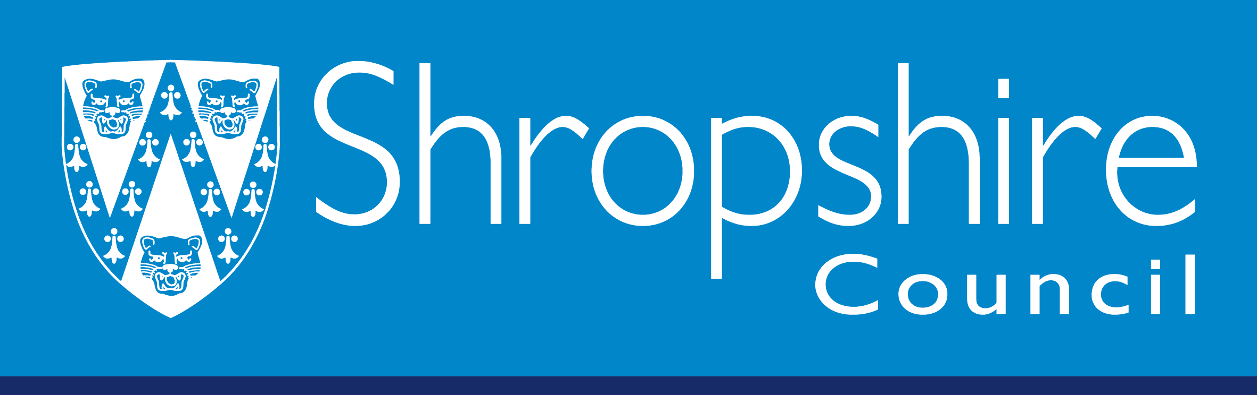

‘Awaiting Inspection’ Status Self-Certification Application Form for Food Businesses Rated 0,1 or 2

Name of Business:
Address:
Date of Inspection:

Due to Covid 19 restrictions Shropshire Council Health Protection Team is not currently undertaking ‘Request for Rescore’ visits. If your business has been given a 0,1 or 2 rating it is possible upon receipt of satisfactory evidence of compliance, your food business score can be altered to ‘Awaiting Inspection’.

Please provide evidence you have complied with the Legal Requirements in this Departments letter or report of visit following your inspection. Detail below each item in the letter or report confirming your actions taken to comply. Please also provide photographs and copies of records where appropriate.

It is preferable this form is emailed with the evidence to food@shropshire.gov.uk.

Item Number: | Action taken to comply:

Name: |  | Position:
Signature: |  | Date:

SELF CERTIFICATION FORM continued:

Item Number: | Action taken to comply:
(Continue on separate paper if required)

Name: |  | Position:
Signature: |  | Date:

SELF CERTIFICATION FORM continued:

Item Number: | Action taken to comply:
(Continue on separate paper if required)

Name: |  | Position:
Signature: |  | Date:

