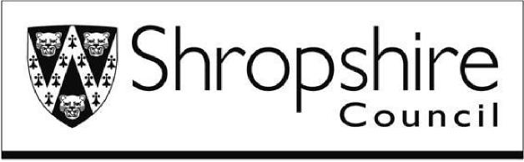 | Licensing Team  Business and Consumer Protection Service  Shirehall  Abbey Foregate  Shrewsbury  SY2 6ND  Email: taxis@shropshire.gov.uk  Tel: 0345 678 9046

Hackney Carriage/Private Hire Drivers Reference Form
In the interests of the travelling public, it is essential that hackney carriage/private hire drivers are completely trustworthy and responsible people. In order for Shropshire Council to determine whether you are a fit and proper person, the Council requires that two satisfactory references are provided.
References can only be provided from either professional or business sources who have known you for at least two years. The Council will not accept references from family members, drivers, operators or vehicle proprietors licensed with any local authority or, where relevant, the applicant’s future employer unless there is satisfactory evidence of exceptional circumstances that are accepted by the Council. The Council reserves the right to refuse a reference where the Council deems the referee is not acceptable.
Please provide the details of two persons who can be contacted regarding your suitability. Shropshire Council will write to these persons for a reference.

Title:
Referee 1.
First name and surname:
Address:
Postcode:
Email address: (the licensing team will forward correspondence via email as the preferred method of contact)
In what capacity do you know this person:
Referee 2.
Title:
First name and surname:
Address:
Postcode:
Email address: (the licensing team will forward correspondence via email as the preferred method of contact)
In what capacity do you know this person:

