Useful information
For Students Living
At Tannery East

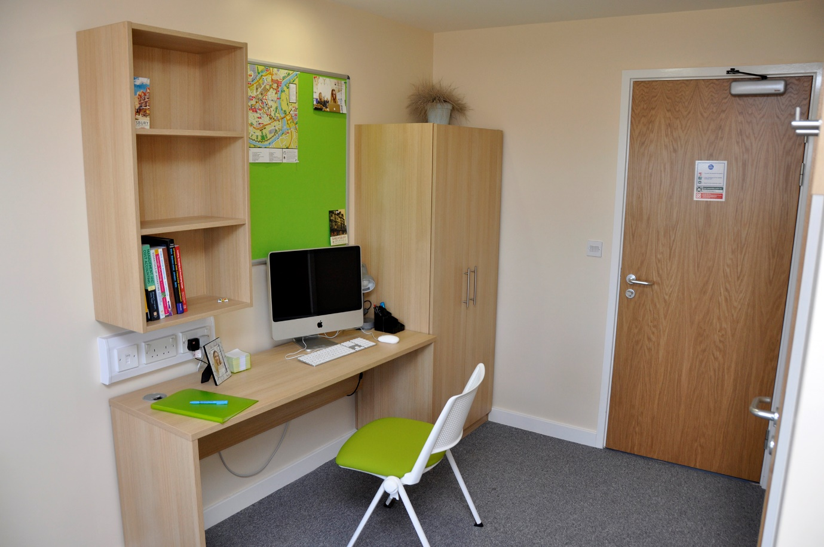

Contents Page
- Introduction 3
- First things first… 3
- Concierge Contact Details 3
- Premises and property matters 3
- Reporting premises and property matters 3
- Access to Student Accommodation/Inspections 4
- Pastoral/Welfare matters 4
- Letters/Mail & Parcels 4
- Your Postal Address 4
- Access control – Using your Key Fob 4
- Window restrictors 5
- Room transfers 5
- Posters and Pictures 5
- Lost Fobs and Keys 5
- Cooking & Cleaning 5
- Wi-Fi access 6
- Laundry 6
- Bicycles 6
- Tannery East Smoking Policy 6
- Security 6
- Fire Procedures 7
- Fire Doors 7
- Smoke/Heat detectors/Fire Extinguishers 8
- Lift 8
- Routine Maintenance 8
- Complaints Compliments and Escalation Arrangements 8
- Accommodation disciplinary procedure & process 8
- Heating and controls 9
- Electrics 9
- En-suite Facilities 10
- Insurance 10
- Overnight Guests 10

1 Introduction
Here at Tannery East, Shrewsbury, we have a great team ready to help and support you to make your time with us a success.
The team have pulled together some useful information to help you settle in quickly and are as comfortable and as safe as possible, please take the time to read and digest this information.

2 First things first…
Please complete your room inventory within 24 hours of arrival and return it to the Concierge. This forms part of your tenancy agreement and is an important check for both you and the team. This will be used again for future room checks and when you leave us to ensure our high standards are maintained. You may be charged for any discrepancies so it’s important that this is completed accurately.

3 Concierge Contact Details
Depending on the nature of your enquiry, you can contact the team in a variety of ways;
Email: concierge.helpdesk@shropshire.gov.uk
In person: on site at Mardol House or at Tannery East at request
Mobile 07990 085610
Please note there may be pockets around the buildings or between buildings where the mobile signal is poor. If you are unable to contact the member of staff on duty please be patient as they may be walking between the halls of residences.
There is a member of staff on duty 24 hours a day, however, the reception desk is not manned 24 hours per day, the Concierge Team have duties that have to be performed in and around both facilities and could be away from the desk for periods of time.

4 Premises and Property matters
Shire Services are responsible for coordinating and running Tannery East Student Accommodation, they want to create a good environment for you to complete your studies so will be happy to help with any premises matters such as repairs and maintenance.

5 Reporting premises and property matters
Your key contacts are the Student Accommodation Concierges who are based at Mardol House reception.
Report any issues you may have in relation to the accommodation to the Concierge team.
The Concierge team will e mail you to confirm that the matter has been reported and will e mail you again to update on the action taken once a contractor has attended to the matter.

6 Access to Student Accommodation/Inspections

The concierge team will not enter student accommodation unless accompanied and performing a specific duty.
Or in the event of an emergency repair that requires immediate attention such as a burst pipe or a leak.
A termly inspection will be carried out however you will be notified of this beforehand and the concierge will be accompanied by a colleague. Students will be notified of any issues that need to be addressed following inspection.

7 Pastoral/Welfare matters
For UCS students there is an Assistant Residential Tutor who lives on site and is available to offer you pastoral support and care. Your Assistant Residential Tutor will introduce themselves to you within the first few days so that you know who they are, how they can support you and where to find them. If you have not been introduced within your first week please speak to the Concierge who will be able to arrange an introduction for you.

8 Letters/Mail & Parcels
We all like to receive mail and letters from home so the team are keen that post and parcels are stored securely, because of this you are asked to collect post from Mardol House reception. The Concierge will email or text you to let you know that there is a parcel / post to collect. Your student ID or other photographic ID will be required to collect your package.

9 Your Postal Address
Please note that the Concierge can only accept post and parcels for residents. Equally if it is unclear from the address details who the recipient is the item may be returned to sender.
Even though you are living at Tannery East for post please use the following postal address;
Your Name
Room number
University Centre Shrewsbury,
Mardol House,
Claremont Street,
Shrewsbury
SY1 1QL

10 Access Control – Using your fob
For your safety and security Tannery East operates a combination of fob and key entry system. Your fob is individually programmed to allow you access to communal facilities and your cluster. Your key will operate your individual room.
Please be mindful that the gate to the premise only unlocks for a short time to allow you to pass through.
The gate access/egress
- Hold the fob in front of the reader (small box approx. mid height near door)
- The gate will unlock for a short time and is manually operated. Please do not push the gate
- To exit from the premise through the gate there is a push button on the left hand side please press this to release the lock and then manually open the gate to exit
Main Entrance access/egress
- To enter hold the fob to the reader and the main door will open automatically
- To exit press the button on the right hand side to release the door it will open automatically
Internal doors
- Hold the fob to the reader and open the door

11 Window Restrictors

For safety reasons, please do not tamper with the safety restrictors on the windows in your accommodation. If restrictors have been altered or tampered with you will be charged.

12 Room Transfers
If you wish to move, we will do our best to transfer you to an alternative room. You can apply to change your accommodation; however, it is often best to settle in for a few weeks before requesting a move. If you wish to be considered for a move, please speak to the Concierge in the first instance. Please also note that an administration cost will be charged if you decide to move.

13 Posters and Pictures
In all areas of student accommodation, posters, pictures and decorations may only be fixed on noticeboards provided by using drawing pins, or on doors by the use of white-tack. Please note that notices, posters and/or decorations must not be fixed on walls, ceilings, windows or in corridors, as this can cause damage. Under your License Agreement, you will be charged for any damage caused, including damage from blue-tack, and drawing pin marks.

14 Lost Key Fobs and Keys
If you lose or misplace your key fob or key please report this to the Concierge as soon as you can. If you are locked out of your room, the Concierge will verify your identity and help you to access your room. You will be charged for replacement kyes and fobs.

15 Cooking & Cleaning
All residents have a responsibility to keep their own rooms clean, tidy and well maintained as well as take a share in maintaining standards by cleaning up after themselves and leaving all communal areas in a clean condition so that everybody can use clean, safe facilities.
You are responsible for:
- Washing your dishes
- Leave the facilities as you would expect to find them
- If you spill something, wipe it up
- Clean the top of the hobs when you have finished
- Do not leave spillages on the hobs to burn
- Do not leave cooking unattended
- After cooking please remember to turn off hobs and ovens
- If you burn food, it may set off the fire alarm
- Keeping the fridge clean, keep the internal drainage free of debris and discard any out of date food.
- Emptying bins in the communal kitchens. Any rubbish bags should be securely tied before being moved and placed in the external Bin Store.
A dust pan and brush will be provided in each kitchen, a mop and bucket and vacuum is available on request, please see the concierge.
The Assistant Resident Tutor, accompanied by a member of the concierge team will inspect the communal kitchens and bedrooms. Bedroom inspections will be at a set time, notified to students in advance.

16 WI-FI Access
WI-FI connection is offered within Tannery East. Simply log onto the network which is SUT WI-FI password is dw1mqJDOCPv5EgT3
Please note this password is for students use and should not be passed onto anyone who is not living within the accommodation.

17 Laundry
There are laundry facilities on site comprising washing machines and tumble dryers. These are located on the ground floor near the entrance. There is a fee for using the laundry. Details of how to use these facilities and what the current charges are for this facility is displayed in the laundrette.

18 Bicycles
There is a bike rack sited at the rear of the building which residents are free to use. Please note that items are stored here at your own risk.
Bikes must not be brought into the accommodation.

19 Tannery East Smoking Policy
In the interests of safety and public health, smoking of cigarettes including electronic cigarettes is not permitted within Tannery East (including common areas). All bedrooms are fitted with smoke detectors. Fines may be issued to those who ignore the above rule.
Smoking should only take place off site and away from the main gate. Smokers are asked to be considerate of other people in the vicinity when they are smoking and to dispose of used cigarettes carefully, both to avoid litter and risk of fire.

20 Security
We provide a secure environment and ask for your help to maintain our high standards by following this security guidance;
- Bedroom and corridor doors must always be closed; wedging open a fire door is not only a fire risk, but a security risk
- Do not leave valuable or personal items in communal areas
- Do not allow strangers in through doors. If you are in doubt close the gate or door behind you and inform the Concierge
- If you see someone in the accommodation who doesn’t look like they should be there or cause you to be suspicious please contact the Concierge
- Concierge have the right to refuse entry to non-residents
- Be mindful of taking photographs of fellow students and staff within the building check they are in agreement

21 Fire Procedures
Tannery East has been built to a very high standard and offers residents a high degree of protection in the event of a fire.
The fire alarm will be tested between 2.30m and 2.45pm every Tuesday, the alarm will sound briefly twice. If the alarm sounds for an extended period of time on a Tuesday afternoon, please evacuate the building.
Student Action on Discovery of a Fire
On discovering a fire close the door of the room where the fire has started if it is safe to do so and immediately raise the alarm by activating the nearest fire alarm call point.
If there are flames, phone 999 from nearest safe phone, giving the exact location, extent and severity of the fire and evacuate the building.
Activation of Audible Alarm in Student Rooms and Kitchens
If detector activated, the electronic sounder will sound in the actual room or kitchen and on fire alarm panel. There is an Alarm-Calm reset button which will give an individual (room only or kitchen only) a 1-minute time frame to press the reset button, then a further 3 minute reset period in order to clear the smoke which caused the initial activation. If this is not completed within this time frame the fire alarm system will be reactivated and subsequently trigger a full activation of all the rooms and kitchen(s) in that particular cluster area. Please note that the Alarm-Calm button can only be reset once per activation.
The fire alarm system is based on a stay put system, this being the case each cluster is programmed as an individual area with full activation given on a double knock basis, i.e. if corridor detectors are activated this will trigger a full activation and automatically go into full evacuation and Shropshire Fire and Rescue mobilised.
The fire alarm evacuation signal consists of an electronic sounder which indicates that all occupants are required to evacuate the premises immediately, following signs to the nearest fire exit and then to the assembly point. Tell others in your accommodation to evacuate as you leave.
If a call point is activated within the four-minute delay period then the panel goes into full evacuation and Shropshire Fire & Rescue mobilised.
Activation of Audible Alarm in Circulation Areas, Cleaning Cupboards, Stairwells, Entrance Lobby, Lift Shaft, Plant Rooms, etc. will result in a full evacuation and Shropshire Fire & Rescue mobilised.
The evacuation point is at Rowley’s House opposite the Tannery East Building.
22 Fire Doors
For safety fire doors are designed to self-close, please do not prop them open or adjust any of the fixtures or mechanisms as this could put yourself and others at risk.

23 Smoke/Heat Detectors/Fire Extinguishers
Please do not cover or tamper with the smoke and heat detectors on the ceilings. This will make them ineffective and unable to protect you and others.
Please do not remove tags from the fire extinguishers.

24 Lift
The lift is monitored 24 hours a day by Remote Elevator Monitoring. In the event that the car stops between floors please press and hold the alarm button until the button is illuminated.
If the button is pressed when the lift IS NOT in fault it requires pressing for up to 20 seconds to enable call out. There can be a delay in these calls being answered because the lift can detect if it is in fault mode or not. This helps the call centre prioritise call answering.
If the lift is in a fault mode e.g. stuck between floors/or jammed, the call button works straight away without the need to press for an extended time as the lift will detect this and calls are answered in the correct timeframe of 7 – 10 seconds

25 Routine Maintenance
There are occasions when Routine Maintenance needs to be carried out within student accommodation by the Concierge team or Contractors, such as emergency lighting checks. You will be notified in advance when these are due to take place.
Daily building checks will be undertaken by the Concierge team usually mid-morning to identify any defects or maintenance requirements within the communal areas.

26 Complaints, Compliments and Escalation Arrangements
The concierge team is the first point of contact. If you have already been in touch with them and remain unhappy or wish to share praise, please escalate the matter to the managers shown below.
If you have any issues with the accommodation at Tannery East that you do not feel are being dealt with in a timely or appropriate manner by the Concierge Team, please contact the following members of the Facilities Team who are available to discuss and resolve your concerns.

Jacky Hammett Area Manager
Telephone 01743 250273 E mail jacky.hammett@shropshire.gov.uk
Janet Croft Service Manager
Telephone 01743 250258 E mail janet.croft@shropshire.gov.uk

27 Accommodation disciplinary procedure & process
Students are asked to consider the wellbeing of others and behave appropriately in Tannery East. The facilities team have an obligation to address issues of antisocial behaviour and health and safety infringements, these matters will be raised with the ART to address with the students concerned.
Students are expected to be in appropriate dress when in reception and other public areas of the building.
Your Accommodation Handbook, Accommodation Policies and Tenancy Agreement highlight full details of the behaviours that are expected and how unacceptable behaviours are addressed, below is an example of behaviours that are unacceptable.
To help create a safe, happy and healthy environment to live, study and relax, students are asked to consider others when they are in the building.
Issues which the Concierge team will report to the Facilities Support Team include: -
• Smoking including vaping
• Making excess noise
• Damaging property
• Creating Health and Safety infringements
• Causing false or malicious fire alarm activations
• Antisocial behaviour
• Your guests causing problems in accommodation
• Security breaches
• Leaving facilities in unclean, unsafe condition
• Intimidation and bullying

28 Heating and Controls
The electric wall heater is the latest technology and is an intelligent system. It is pre-set to 21 degrees and detects motion and presence when you are in the room. It will automatically adjust when you are out and then reacclimatise when you are in the room.
Do not cover the heater, this is a fire risk and steam produced from wet clothes can falsely activate the fire alarm. It can also cause the heater to break as the heating elements can over heat.
If your heating is not working please inform the Concierge for assistance.

29 Electrics
The plug sockets have been labelled for specific use. Please do not plug other appliances into these, as you may ‘trip’ the electrics which will cause a break in the electric supply. If the circuit has tripped, the Consumer Unit which is on the wall as you enter the shower room will activate and the trigger switch or breaker will be in the ‘off’ position. Ensure you remove the offending plug before switching the circuit to the ‘on’ position, to restore power. If in any doubt, please speak to your Concierge.
Students must not tamper with any of the electrical fixtures or fittings, please report any issues to the concierge.

30 En-suite Facilities
Please check the drain in the shower regularly and remove any blockage. Ensure water is able to drain freely. Do not leave taps and showers running unnecessarily as this can cause leaks and flood the bathroom.
When cleaning your shower please do not use anything abrasive such as a souring pad or an abrasive cleaning chemical as this will scratch the surface.

31 Insurance
A basic insurance is provided, however you will need to arrange cover for expensive items and may want to extend the cover to provide additional cover.

32 Overnight Guests
Whilst overnight guests are permitted, they should not be staying overnight on a regular basis. Visitors are only permitted to stay overnight for a maximum of two consecutive nights in any 7-day period. Students are also asked to be mindful of other students particularly in shared cluster rooms where you will be held responsible for any actions taken by your guest. Your guests should not be using the kitchen facilities, cooking, and using food from cupboards or fridges. Your guests should not be left in the accommodation unsupervised.

We hope you find this information useful but if you have any questions please contact the Concierge who will be happy to help.

All policies and procedures relating to the student accommodation at Tannery East
are available to view in full on the website.
www.shropshire.gov.uk/mardol-house-student-accommodation/

Version 7.00
Reviewed August 2023
Next Review Date August 2024

